**For refugees, another risk: Schizophrenia**

By [Elahe Izadi](http://www.washingtonpost.com/people/elahe-izadi) March 16

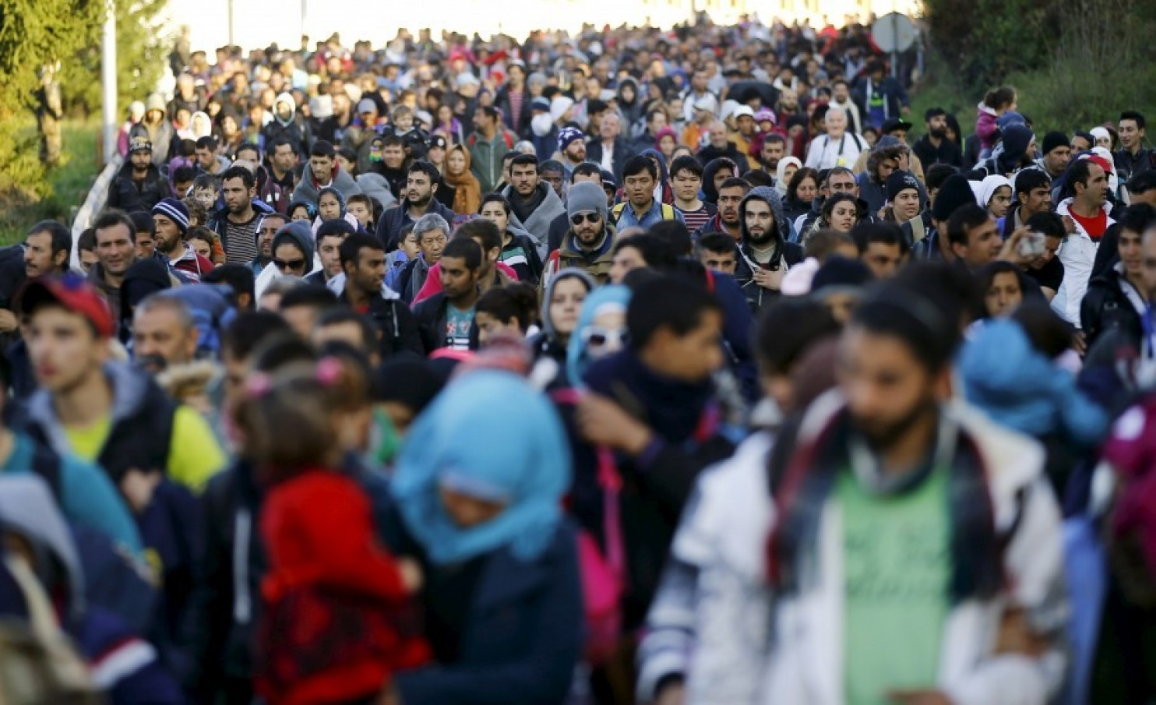  
Migrants walk toward the Austrian border after resting in a makeshift camp in the village of Sentilj, Slovenia, on Oct. 24, 2015. (Leonhard Foeger/Reuters)

The trauma of fleeing persecution, war and natural disasters can leave a lasting mark on a person. And a new study underscores just how dramatic the effect of such life experiences can be for refugees.

Refugees face a much higher risk of experiencing psychotic disorders, such as schizophrenia, than native-born residents and other migrants, according to a study of 1.3 million people in Sweden.

According to the research, [published Tuesday in the journal BMJ](http://www.bmj.com/content/352/bmj.i1030), refugees were three times as likely to experience schizophrenia and other psychoses as native-born Swedes.

Refugees were also two-thirds as likely to develop such disorders compared with people who migrated from the same regions but for other reasons, such as economic factors.

“The dramatically increased risk among refugees shows that life events are a significant risk factor for schizophrenia and other psychoses,” lead author Anna-Clara Hollander, of Sweden's Karolinska Institute, said in a release.

Refugees are already known to be especially vulnerable to developing post-traumatic stress disorder and depression. But researchers in the Sweden study say theirs is the first to examine the risk of schizophrenia and other psychoses.

The data researchers used came from Sweden's national registry, which tracks immigration and health status for individuals. Included were 1.3 million people who born after 1983 and  followed from their 14th birthday until the end of 2011. Of this group, 3,704 experienced a psychotic disorder.

Those included in the study migrated from four major regions: Middle East and North Africa, sub-Saharan Africa, Asia and Eastern Europe, including Russia.

“These differences cannot be explained by other, important alternative explanations like differences in age, sex, income or urban residency," [said](https://www.youtube.com/watch?v=YA-w9joJ-x0) co-senior author James Kirkbride of the University College London.

Refugees from sub-Saharan Africa faced the greatest risk for experiencing schizophrenia, he added.

The study authors write that the adversities refugees experience, including "social, economic, and health inequalities," probably contribute to an increased risk for mental health disorders.

Sweden has historically taken in large numbers of asylum seekers; in 2015, it received more applications from such individuals per capita than any other European nation. But [more recently](https://www.washingtonpost.com/world/europe/even-sweden-is-turning-its-back-on-refugees/2015/12/30/6d7e8454-a405-11e5-8318-bd8caed8c588_story.html), the Swedish government has changed the benefits it offers such individuals and implemented new border controls to stem the tide.

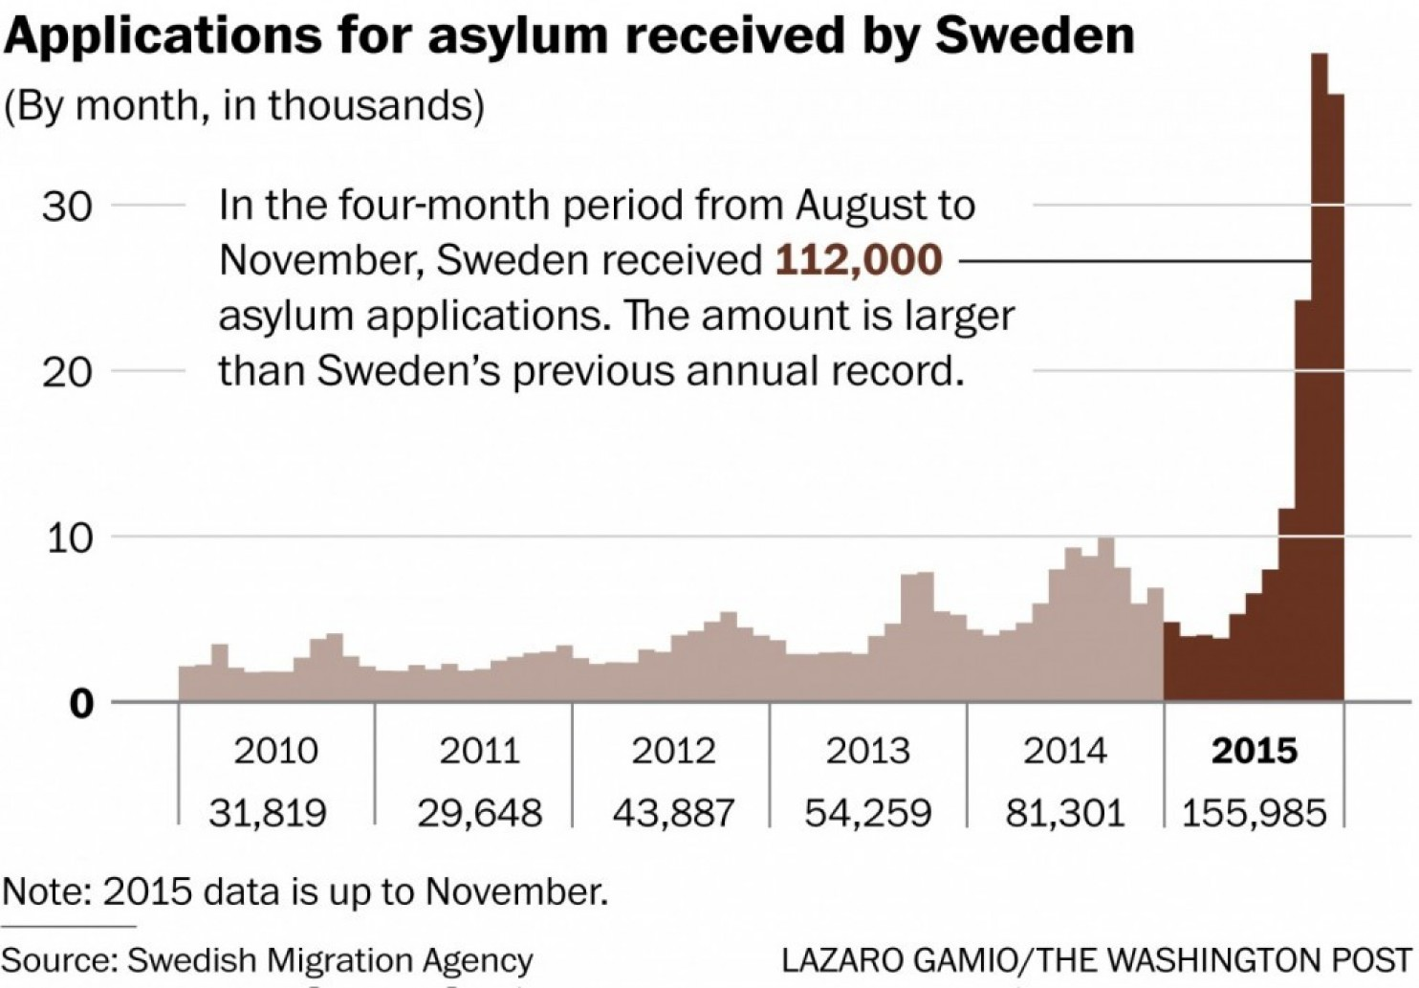

"In most countries refugees undergo standard health checks, but mental health issues can be overlooked," Kirkbride said in a release. "Like all people, refugees would benefit from timely and early treatment of any mental health problems.”

While the dataset doesn't include the most recent refugees and migrants, the study authors write that their findings could presumably apply to those currently seeking refuge in Europe from conflicts in Syria, Iraq, Afghanistan and elsewhere.

"We presume that exposure to war, persecution, and exposure to other psychosocial adversity would have a universal effect on individual risk of psychosis, independent of other risk factors," they write.

The authors note that they couldn't measure post-migratory factors, such as racism and discrimination, to see what kind of effect that had on psychosis.

That's an element highlighted by Cornelius Katona, medical director of the human rights group Helen Bamber Foundation.

"Consideration also needs to be given to the challenges that asylum seekers face during what is often a prolonged and distressing process," Katona [writes in a separate commentary](http://www.bmj.com/content/352/bmj.i1279) on the study published by BMJ. "These factors may include institutional detention, inability to work (and resultant deskilling and loss of self-esteem), destitution, and difficulty in accessing health and social care."